Catalog No. : 53-*-937R | 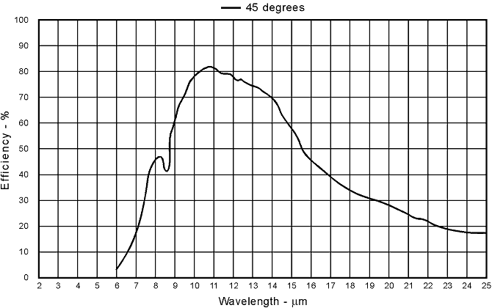
  Diffraction Order : 1
  Master No. : 1070
  Groove Frequency :
  50 g/mm
  Grating Type :
  Plane Ruled
  Coating :
  Aluminum
  Nominal Blaze Angle :
  17.5°
  Blaze Wavelength :
  12 μm
  Maximum Ruled Area :
  64 x 64 mm
  Remarks :
  Note: Efficiency curves shown are relative (not absolute), are only representative, and can vary significantly depending on use geometry and measurement technique. Two masters with the same catalog number may have different efficiency curves. The uncertainty band on the data in the above relative efficiency curve(s) is +/- three percentage points. Maximum Ruled Area is expressed as L x W, where L is the length of the grooves and W is the ruled width.
©2008 Newport Corporation All rights reserved.

